Create the following graph using neo4j and answer the following query

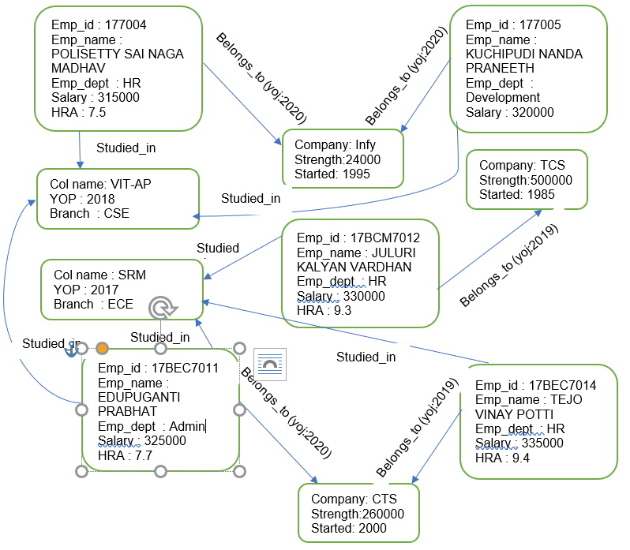

1. Display all student in ascending order
2. Display all company details in upper case letters
3. Display the employee who is getting highest salary
4. Find the average salary of CTS employees
5. Find the minimum salary of Infy employees
6. Find the employees count who are all working in Infy and CTS
7. Find the employees who are working in HR and Admin department
8. Find the employees who are working in Admin or Development department
9. Create unique constraint on emp_id
10. Create index on all the companies nodes